**SOES6011 Assignment 2 Model Answer**

**Abstract**

We expect a concise well written summary, setting out:

a. What is the problem?

b. Approach and anything novel about it?

c. Key results and interpretation of the findings

d. So what? Summarise main points and why these are significant.

**Introduction**

We expect a well-written introduction that has at least these elements:

* the motivation of the study, ideally setting the scene in a broader context.
* a brief background to Southampton Water, which might include the geographic setting; the importance of the estuary in terms of the Port, trade, shipping etc, and some key physical characteristics, such as the height and unusual nature of the tide, sediment transport etc.
* the aim of the study, which is to assess changes in the water volume of Southampton Water due to sea-level rise and contrast this with various specified anthropogenic changes.
* an outline of the structure of the report.

**Methods**

We expect this section to include a brief description of the ASMITA model and what it does, along with a short description of how it has been set up for Southampton Water. We expect the section to be something like the following.

*To assess the changes due to sea level rise and huma interventions some form of morphological model is required. For a rapid assessment with limited data, the ASMITA model is well-suited to the task. The model aggregates change within defined elements and uses an equilibrium based on the tidal prism as a proxy for equilibrium sediment concentration. For this application, the estuary has been schematised using 4 elements, comprising an outer channel and flat and an inner channel and flat. The model was run without and with the nodal tide and with the inclusion of historical changes. A dredged channel was introduced into the two channel elements, 200m wide, 2m deep and 18km long, requiring the removal of 7.2Mm3. The reclamation removed an area of 0.2Mm2 and a volume of 0.5Mm3 from the inner tidal flat.*

*NB: the following results assume that the student has omitted to include the maintenance dredging. For this case to run the equilibrium concentration will need to have been reduced. The following results used cE=0.01.*

**Results**

We expect the students to show figures containing the variation of water volumes (moving surface volumes), morphological volumes (fixed surface volumes) and equilibrium volumes and to tabulate the changes between 1900 and 2100. The following are typical possible outputs.

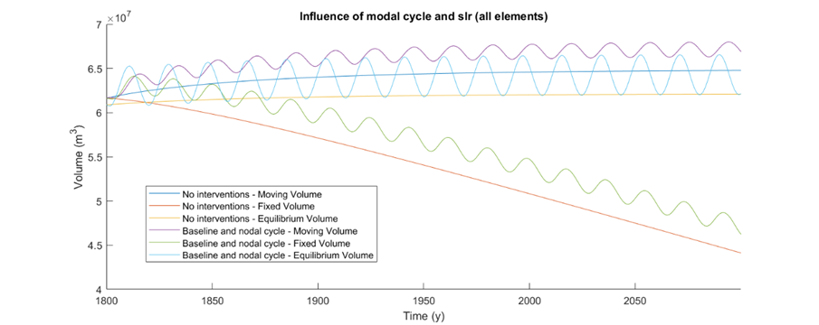

Figure 1: Volume changes from ASMITA for sea level rise and nodal fit

The impact of the 3 interventions is shown in Figure 2 for moving or water volumes (upper plot) and morphological or fixed volumes (lower plot) and the changes between 1900 and 2100 are summarised in Table 1.

|  |
| --- |
|  |
|  |

Figure 2: Moving volume changes from ASMITA for dredge and reclamation

Table 1 – Summary of changes between 1900 and 2100 for the various cases studied (NB: this case excludes maintenance dredging and only runs with a smaller value of cE. Results shown are for cE=0.01)

|  |  |  |
| --- | --- | --- |
| Case | Moving surface volume  (water volume change) | Fixed surface volume  (morphological change) |
| 1 – sea level rise of 2mm/year | 1.00E+05 | -1.38E+07 |
| 2 – As 1 with nodal cycle of 0.15m | -4.00E+05 | -1.49E+07 |
| 3 – As 1 with historic changes | 5.00E+05 | -1.19E+07 |
| 4 – As 3 with dredge in 2020 | 4.40E+06 | -8.00E+06 |
| 5 – As 4 with reclamation in 2030 | 3.70E+06 | -8.60E+06 |

The results text should be something like:

*The four cases examined are detailed in Table 1 and illustrated in Figure 2. Substantial changes in the twentieth century have clearly dramatically changed the evolution that would have happened under sea level rise alone. This puts in context the much smaller changes introduced in the years 2020 and 2030. The proposed dredge further exacerbates the increase in volumes of the system and this impact is slightly reduced by the subsequent reclamation, although the reduction is comparatively small. Table 1 also summarises the changes in total volumes and the morphological change. These can be compared with the annual volume change due to sea level rise of 2mm/year, which over 200 years would be an increase of 1.4e7 m3. Thus under sea level rise alone the system accretes (negative morphological change) at approximately the rate of sea level rise. However the historical change exceeds this so that the system is unable to infill at a rate compatible with sea level rise (reducing the fixed volume change by 4%).* *The proposed dredge increases this impact by further reducing the fixed volume change by 9%, with a small offset in these changes when the reclamation is added.*

**Discussion**

In the discussion section we expect the students to relate the key findings in light to the relevant literature. We want them to discuss which of the 4 scenarios has the biggest impact and why, and how the new changes compare with the historical changes. We also expect the students to briefly discuss the assumptions of the ASMITA model. This should include consideration of what other modelling approaches could be used and how are they likely to compare with the approach adopted for this exercise (strengths and weaknesses)?

**Conclusion**

We expect the students to briefly describe the key findings. We expect a conclusion section something like as follows:

*The results highlight the significant impact of the historical changes and the further impact likely to result from the proposed channel deepening. By comparison, the reclamation is shown to have a relatively minor effect. These results also provide a basis for testing and evaluating the results from more detailed process modelling studies.*

**References**

We would expect around 10-20 references, including some that have been published in the last few years. We would like the articles to be properly cited in the main text, and for the formatting of the reference list to be consistent.

**Figures/Tables**

We expect no more than 4 figures. We would like all figures and tables to have an appropriate caption. We would like the text size of the figures to be appropriate, and all axis correctly labelled, include units.